Test Cases Report for English Monolingual Model
In some cases, it misidentsifies Neutral and Negative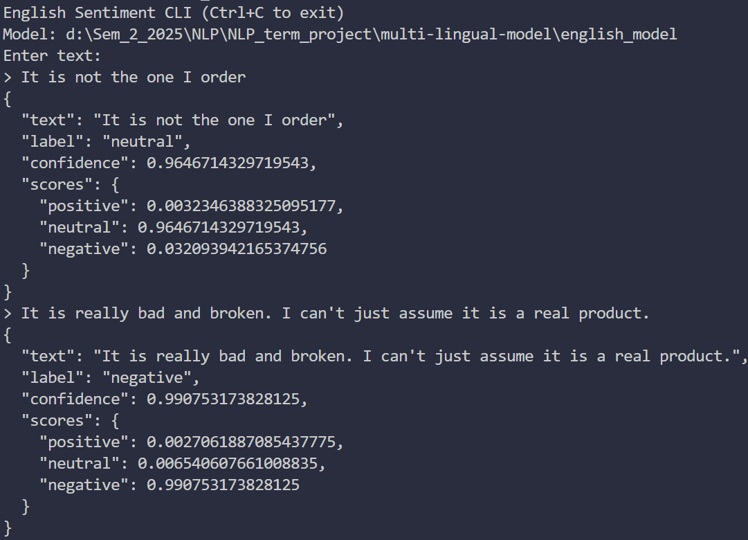
Same issue for Neutral and Negative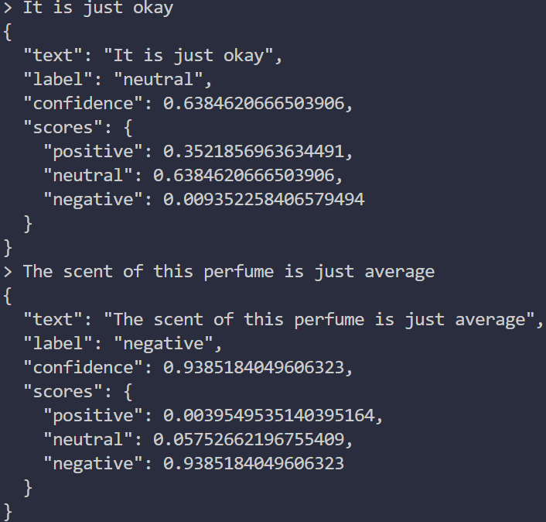Positive confidence is correct but this model struggles between Neu (0.40) and Neg (0.58)
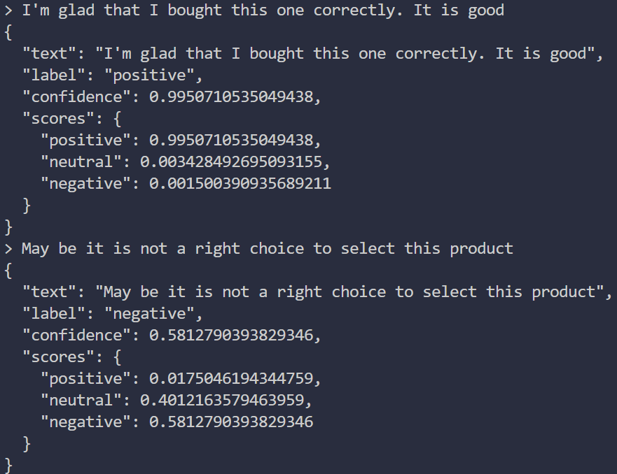
It can identify question as Neutral with high confidence score